Kulaluk Mud Crab Farm [“CRABGATE”]. Comment on Appendix 3 of Heasman report 2007, p.127.
Comments by Dr Bill Day, December 2016.

From: Appendix 3. Environment Management Plan For Gwalwa Daraniki Enterprises Pty Ltd Mudla Farms
Prepared by: T Angeles (GDE), I Ruscoe (NT Fisheries) and RA Rose (TAA) 23/08/2005. In Heasman, Michael P & H M Heasman and Associates 2007 “Review of the Gwalwa Daraniki Enterprise (GDE) mud crab (Scylla serrata) pond farming project at Kulaluk, Darwin and comments on the Bawinanga Aboriginal Corporation (BAC) mangrove pen mud crab farmingproject at Numungoorda, Maningrida, Northern Territory, Australia.” Deakin West, ACT: Department of Agriculture, Fisheries and Forestry and Fisheries Research and Development Corporation. September 2007.
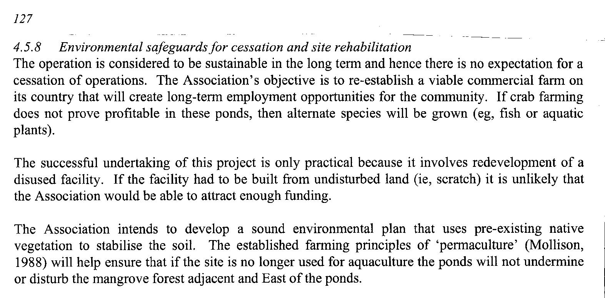
“Environmental safeguards for cessation and site rehabilitation”: Despite the project being “considered to be sustainable in the long term...” The crab farm was abandoned two years later. The only “alternative species” to be grown in the ponds since the project was abandoned are mosquitoes.
According to this report, “the project is only practical because it involves redevelopment of a disused facility” (the failed prawn farm). It seems nothing was learned from the failure of the prawn farm (a scandal in itself) and according to the development permit, if the prawn farm failed, the land had to be restored – this was never done. Showing no concern for the environment, 2009 the GDA included the abandoned aquaculture ponds in a “non lapsing caveat” granted to Gwelo Investments for a canal housing project that included the Ludmilla Creek and the tidal creek's mangrove forest. The creek and mangroves were included on the Kulaluk land grant because of the areas significance to the Larrakia and Bagot people.
The [Gwalwa Daraniki] Association's “sound environmental plan” has allowed woody weeds (coffee bush) to intrude deeper into the lease, forming a dense was on top of the abandoned pond walls. The salt pan that was ripped up for the ponds was a roosting ground for endangered migratory birds protected by international treaties. For an alternative view, see Day, W B 2008 “Recommendations for a Kulaluk Wilderness, Heritage and Education Park: A last opportunity to be true to the vision of its founders?” Report to Larrakia Nation Aboriginal Corporation.

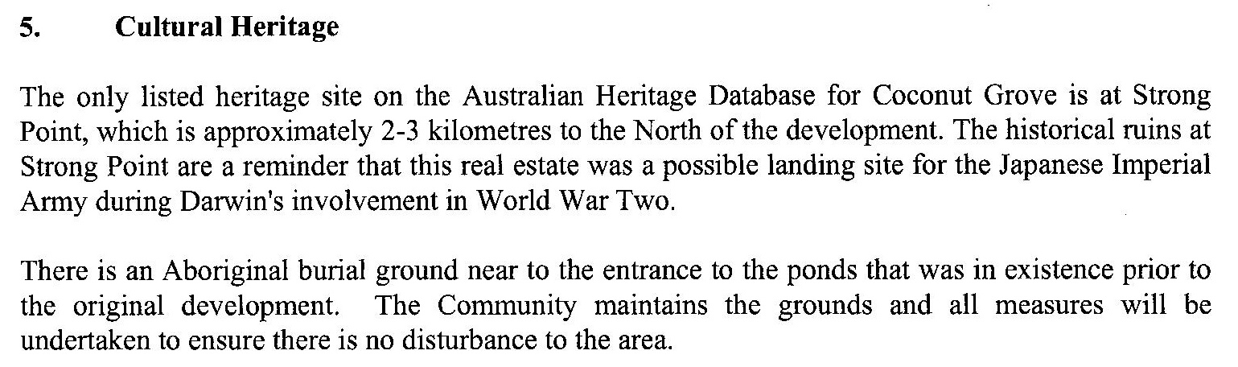
Cultural Heritage: The report's comment about 'the only listed heritage site” shows the importance of registering sites, considering there are several sites nearby, and indeed the creek and salt pan could also be included as sites; however, it was no thought necessary to register sites on the Kulaluk lease area after the land was returned to Larrakia people. It was thought the land was then in safe hands. One of the last remaing concrete bunkers is on hidden on the beach right of was close to the ponds. Even the burial grounds mentioned in this report saying “all measures will be undertaken to ensure there is no disturbance to the area” have not been not safe from developers. The entire burial grounds are included in the Gwelo caveat and in May 2014, Ernie Chin's company, Dragon Lady Pty Ltd cleared 2.5ha of land at the burial grounds with the approval of the leaseholders who were the cultural consultants for the Aboriginal Areas Protection Authority (AAPA), despite a blatant conflict of interest. Similar disregard was shown for historical ceremony sites behind Bagot Aboriginal Community and between Totem Road and Fitzer Drive (see You Tube videos of ABC news reports).
After these breaches, to ensure protection of Larrakia sites, in 2014 the Larrakia Nation Aboriginal Corporation (LNAC) nominated the whole lease as a heritage site. This nomination was supported by a report to the Heritage Council in 2015 (Ritchie, David 2015 “Review of the Assessment Process Carried Out in Relation to the Kulaluk Lease Area”. A report prepared for the Northern Territory Heritage Council. Capricornia Consulting, 31 May 2015.)
Also see Burial grounds bulldozed
http://www.drbilldayanthropologist.com/resources/Vowles_Totem%20Road.pdf

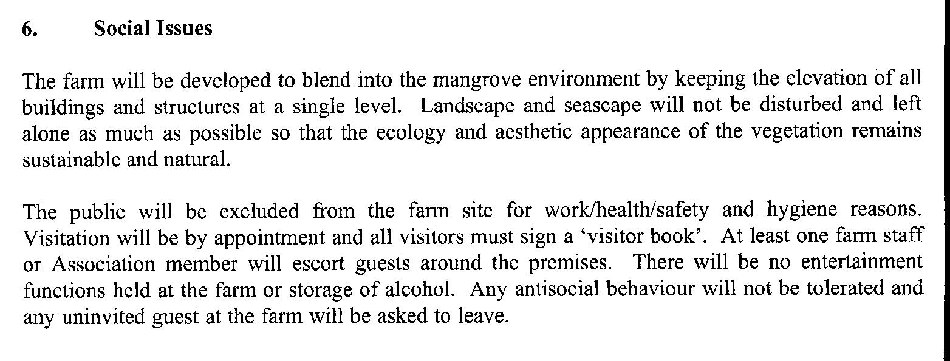
Probably even more significant than the environmental damage is this assessment of “Social Issues” in the report. There is no mention of the cultural use of the area for Aboriginal ceremonial, recreational and hunting and gathering, the very reasons the land was returned to Larrakia people. For example the earthworks have cut traditional foot trails and “no trespassing” signs have deterred Aboriginal people from using crabbing and fishing grounds along the Kulaluk beaches and creeks. The report makes this clear when it says “The public will be excluded from the farm site … Visitation will be by appointment and all visitors must sign a 'visitor book.'” The ponds may be only 5ha of a 301ha lease but their long strategic position parallel with the beach and the associated power lines, water pipes, access roads and work areas have stopped almost all traditional use of the land granted for community use (see Henderson, Krimhilde 1983 Land Use Field Study of the Kulaluk Area. Darwin: Aboriginal Sacred Sites Protection Authority).

Also see:
Hewitt, Sharon 2006 “'Our Vision to Economic Independence and Employment and Educational Opportunities for our Community': an evaluation of the Gwalwa Daraniki Enterprises Mud Crab Farm Employment Program, 'How effective is the delivery of the employment program?'” Prepared by Sharon Hewitt to meet course requirements of a third year Project, Batchelor of Applied Science, Indigenous Community Management and Development, Curtin University, Perth, WA. 2 October 2006.

Costello, Peter 2006 Doorstop Interview, Kulaluk Mudla Farms, Darwin, Tuesday, 16 May 2006, 2.30pm. SUBJECTS: Mudla crab farm, Royal Darwin Hospital Oncology Unit, Macquarie Bank salaries, Indigenous Affairs, funding for new Indigenous housing. Treasurer of the Commonwealth of Australia.

Day, Bill 2011 “'CRABGATE' An illustrated History of the Kulaluk Crab Farm Debacle. Compiled by Dr Bill Day Consulting Anthropologist.” www.drbilldayanthropologist.com

